Project Requirements and Submission Schedule
This document covers Phase 1. Every student must participate in and contribute to all three phases.
Phase 1 deadline: 7 November 2026
Phase 2 deadline: 30 November 2026
Phase 3 and final submission deadline: 20 December 2026
Artificial intelligence policy: If the reported artificial intelligence generated content percentage for a phase is greater than 20%, deduct 4 marks from that phase. Apply the deduction separately to each phase.
Phase 1 content
- Introduction (1500 words with 10 references at least )
- General background about the topic
Example
“Cross-site scripting (XSS) represents a security flaw wherein a web application permits users to embed harmful scripts into web pages seen by others. This widespread vulnerability among web applications can lead to severe consequences such as data theft and session hijacking [1], [2]. XSS attacks transpire when untrusted data is integrated into a web page without appropriate validation or encoding, enabling attackers to implant malevolent scripts (typically in JavaScript). Consequently, these scripts execute when other users access the page. Figure 1 delineates the three main categories of XSS attacks”
- Figure for classification (if available)
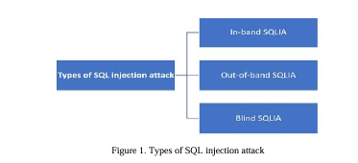
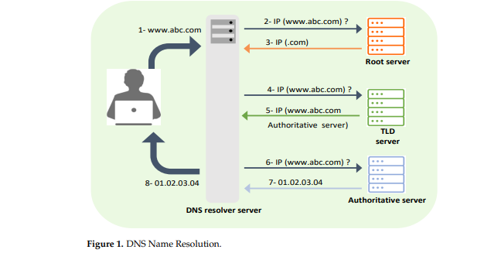
- Contributions you will introduce
Example
“The main contributions of this work are as follows:
- We introduce a pioneering watermarking model designed explicitly for medical images, leveraging the Frequency Domain Curvelet Transform (FDCuT).
- This innovative approach dissects medical images into distinct frequency sub-bands, offering a unique and effective solution for watermark embedding in the medical imaging domain.
- Our paper conducts an extensive comparative analysis, evaluating the performance of the proposed algorithm against contemporary methodologies. Performance metrics, including Peak Signal-to-Noise Ratio (PSNR) and maximum embedding capacity, provide a thorough assessment, highlighting the strengths and advantages of our model in securing medical images.
- The algorithm presented in this paper is meticulously crafted to achieve an optimal balance between robustness, imperceptibility, and computational efficiency.
- Our approach incorporates RSA encryption to augment the security of medical images. By integrating public-key cryptography, we establish an additional layer of protection, safeguarding sensitive medical data against unauthorized access and ensuring the confidentiality of embedded information“
- Prior works (Literature Review)
- You should list at least 15 previous works that discuss your topic, with a summary for each one of them and cited
Example
“Alarfaj and Khan [19] introduced a model that employs a probabilistic neural network (PNN) to identify instances of SQL injection attacks. To optimize the model’s performance, the authors utilized the BAT algorithm, a metaheuristic optimization technique, to determine the most effective smoothing parameter. This study utilized a dataset containing 6,000 instances of SQL injections and 3500 normal queries. Features were extracted through tokenization and regular expression-based methods, followed by selection using Chi-Square testing. Kavitha et al. [20] introduced an approach to prevent SQL injection by employing four distinct classifiers: Support vector machines (SVM), artificial neural networks (ANN), boosted decision tree, and decision tree. This study utilized a database comprising 1100 vulnerable SQL injection samples. Comparative analysis among the classifiers revealed that the decision tree exhibited superior performance, albeit at the cost of significant processing time. ”
Table to summarize prior works


